**Nome: Richard Santos P. 2C ETEC MCM**

**MySQL comando Select**

**1) Selecione nome e dataNascimento dos alunos que começam com a letra "X".**

[SELECT](http://localhost/phpmyadmin/url.php?url=https://dev.mysql.com/doc/refman/5.5/en/select.html) nome,datanascimento FROM `cliente` WHERE nome [like](http://localhost/phpmyadmin/url.php?url=https://dev.mysql.com/doc/refman/5.5/en/string-comparison-functions.html" \l "operator_like" \t "mysql_doc) 'r%';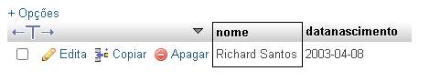

**2)Selecione nome e telefone dos alunos que nasceram no mês x;**

[SELECT](http://localhost/phpmyadmin/url.php?url=https://dev.mysql.com/doc/refman/5.5/en/select.html) nome,telefone FROM `cliente` WHERE month(datanascimento)='07';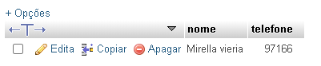

**3)Selecione nome e telefone dos alunos que nasceram no ano x;**

[SELECT](http://localhost/phpmyadmin/url.php?url=https://dev.mysql.com/doc/refman/5.5/en/select.html) nome, telefone FROM `cliente` WHERE [year](http://localhost/phpmyadmin/url.php?url=https://dev.mysql.com/doc/refman/5.5/en/date-and-time-types.html)(datanascimento)='2003';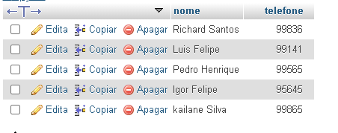

**4) Ordene os alunos em ordem decrescente por Turma;**

[SELECT](http://localhost/phpmyadmin/url.php?url=https://dev.mysql.com/doc/refman/5.5/en/select.html) \* FROM `cliente` ORDER BY turma desc;

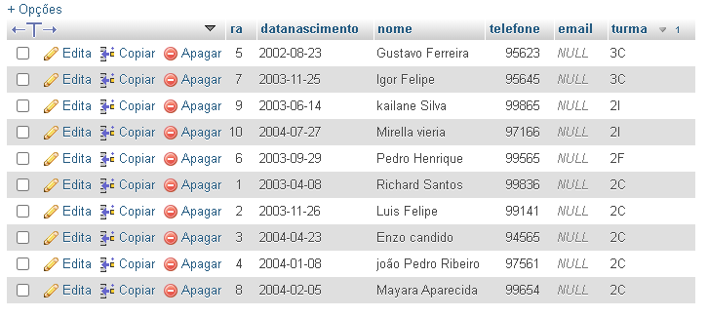

**5) Selecione os livros do Gênero "X";**

[SELECT](http://localhost/phpmyadmin/url.php?url=https://dev.mysql.com/doc/refman/5.5/en/select.html) titulo, autor, genero FROM `livro` WHERE genero = 'Literatura fantastica';

[SELECT](http://localhost/phpmyadmin/url.php?url=https://dev.mysql.com/doc/refman/5.5/en/select.html) titulo, autor, genero FROM `livro` WHERE genero [LIKE](http://localhost/phpmyadmin/url.php?url=https://dev.mysql.com/doc/refman/5.5/en/string-comparison-functions.html#operator_like) '%Literatura fantastica%';

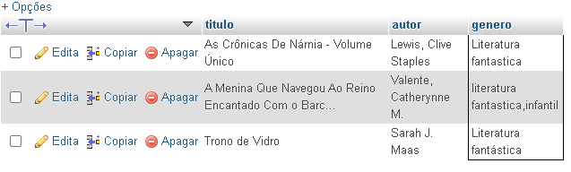

**6) Quantos livros tem cadastrados;**

[SELECT](http://localhost/phpmyadmin/url.php?url=https://dev.mysql.com/doc/refman/5.5/en/select.html) [COUNT](http://localhost/phpmyadmin/url.php?url=https://dev.mysql.com/doc/refman/5.5/en/group-by-functions.html#function_count)(\*) from livro

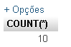

**7) Selecione os livros do autor "X";**

[SELECT](http://localhost/phpmyadmin/url.php?url=https://dev.mysql.com/doc/refman/5.5/en/select.html) titulo,autor,genero FROM `livro` WHERE autor [like](http://localhost/phpmyadmin/url.php?url=https://dev.mysql.com/doc/refman/5.5/en/string-comparison-functions.html" \l "operator_like" \t "mysql_doc) '%Sarah%';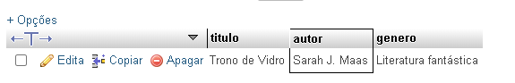

**8) Selecione os empréstimos que aconteceram no mes "X";**

[SELECT](http://localhost/phpmyadmin/url.php?url=https://dev.mysql.com/doc/refman/5.5/en/select.html) \* FROM `emprestimo\_devolucao` WHERE month(data\_emprestimo) = '09';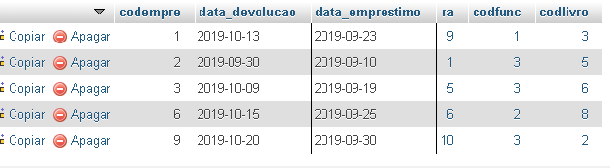

**9) Selecione os empréstimos que aconteceram entre os anos "X" e "Y";**

[SELECT](http://localhost/phpmyadmin/url.php?url=https://dev.mysql.com/doc/refman/5.5/en/select.html) data\_emprestimo,data\_devolucao,ra FROM `emprestimo\_devolucao` WHERE data\_emprestimo BETWEEN '2019-01-01' [and](http://localhost/phpmyadmin/url.php?url=https://dev.mysql.com/doc/refman/5.5/en/logical-operators.html" \l "operator_and" \t "mysql_doc) '2020-12-31';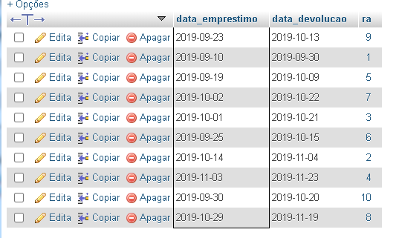

**10) Selecione os bibliotecarios que são da cidade "X";**

[SELECT](http://localhost/phpmyadmin/url.php?url=https://dev.mysql.com/doc/refman/5.5/en/select.html) nome, telefone, cidade FROM `bibliotecario` WHERE cidade = 'Ribeirão Pires';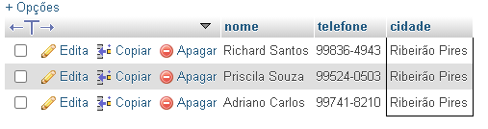

**11)Ordene os bibliotecarios em ordem alfabética;**

[SELECT](http://localhost/phpmyadmin/url.php?url=https://dev.mysql.com/doc/refman/5.5/en/select.html) \* FROM `bibliotecario` ORDER by nome;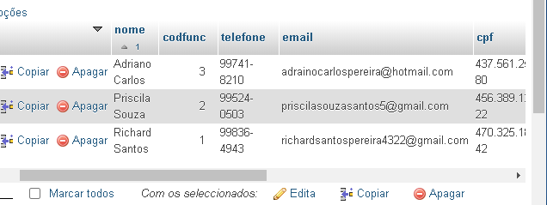

**12) Ordene os livros por gênero;**

[SELECT](http://localhost/phpmyadmin/url.php?url=https://dev.mysql.com/doc/refman/5.5/en/select.html) \* FROM `livro` order by genero;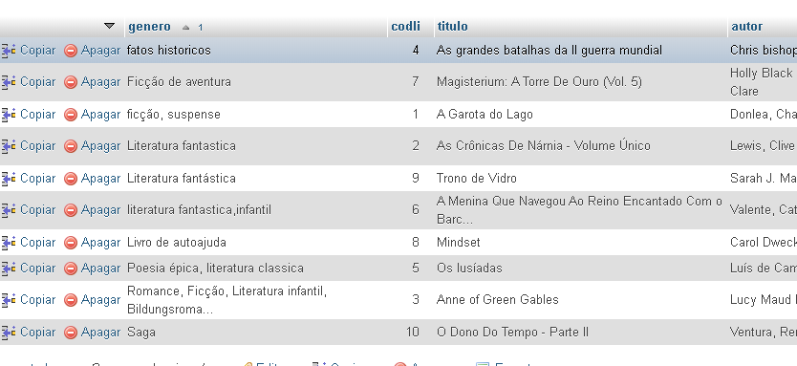

**13) Selecione os livros da editora "X";**

[SELECT](http://localhost/phpmyadmin/url.php?url=https://dev.mysql.com/doc/refman/5.5/en/select.html) \* FROM `livro` WHERE editora [like](http://localhost/phpmyadmin/url.php?url=https://dev.mysql.com/doc/refman/5.5/en/string-comparison-functions.html" \l "operator_like" \t "mysql_doc) '%Escala%';

**14) Selecione os livros dos autores "X" ou genero "Y" e que tenham menos de "Z" páginas;**

[SELECT](http://localhost/phpmyadmin/url.php?url=https://dev.mysql.com/doc/refman/5.5/en/select.html) titulo,autor,genero,paginas FROM `livro` WHERE (autor [like](http://localhost/phpmyadmin/url.php?url=https://dev.mysql.com/doc/refman/5.5/en/string-comparison-functions.html#operator_like) '%Sarah%' [or](http://localhost/phpmyadmin/url.php?url=https://dev.mysql.com/doc/refman/5.5/en/logical-operators.html#operator_or) genero [like](http://localhost/phpmyadmin/url.php?url=https://dev.mysql.com/doc/refman/5.5/en/string-comparison-functions.html#operator_like) '%saga%') [and](http://localhost/phpmyadmin/url.php?url=https://dev.mysql.com/doc/refman/5.5/en/logical-operators.html#operator_and) paginas >100;

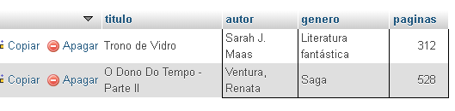

**15) Selecione os livros com titulo que começam com a letra "X" e genero "X";**

[SELECT](http://localhost/phpmyadmin/url.php?url=https://dev.mysql.com/doc/refman/5.5/en/select.html) Titulo,genero FROM `livro` WHERE titulo [like](http://localhost/phpmyadmin/url.php?url=https://dev.mysql.com/doc/refman/5.5/en/string-comparison-functions.html#operator_like) 'A%' [and](http://localhost/phpmyadmin/url.php?url=https://dev.mysql.com/doc/refman/5.5/en/logical-operators.html#operator_and) genero [like](http://localhost/phpmyadmin/url.php?url=https://dev.mysql.com/doc/refman/5.5/en/string-comparison-functions.html#operator_like) '%Literatura%';

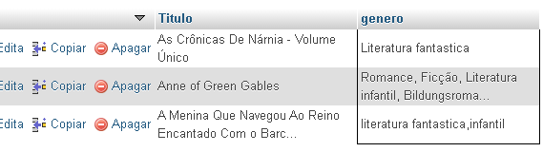

**16) faça a média de paginas de todos os livros;**

[SELECT](http://localhost/phpmyadmin/url.php?url=https://dev.mysql.com/doc/refman/5.5/en/select.html) [avg](http://localhost/phpmyadmin/url.php?url=https://dev.mysql.com/doc/refman/5.5/en/group-by-functions.html" \l "function_avg" \t "mysql_doc)(paginas) from livro;

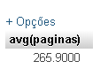

**17) faça a soma de páginas de todos os livros;**

[SELECT](http://localhost/phpmyadmin/url.php?url=https://dev.mysql.com/doc/refman/5.5/en/select.html) [SUM](http://localhost/phpmyadmin/url.php?url=https://dev.mysql.com/doc/refman/5.5/en/group-by-functions.html#function_sum)(paginas) from livro;

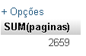

**18) Selecione os livros que tenham entre 4 e 6 exemplares**

[SELECT](http://localhost/phpmyadmin/url.php?url=https://dev.mysql.com/doc/refman/5.5/en/select.html) titulo, autor, genero, qntd\_exemplares FROM `livro` WHERE qntd\_exemplares BETWEEN 4 [and](http://localhost/phpmyadmin/url.php?url=https://dev.mysql.com/doc/refman/5.5/en/logical-operators.html#operator_and) 6

